**Goal 1: Profits**

Gain profits to ensure the company‘s survival.

**Goal 2: Customer Satisfaction**

Maximize customer satisfaction to encourage repeat orders and

referrals to potential customers.

**Goal 3: Technological Edge**

Purposefully develop and maintain a technological edge.

**4.2 The Contract Specifications of Family-Fun Inc.**

**4.2.1 Technical Requirements, Data, and Parameters**

**1.** Length of the track traveled 1000 m

**2.** Maximum height of the track 50 m

**3.** Number of roller coaster cars 3

**4.** Number of passengers per car 36 (9 rows, 4 columns)

**5.** Inversions 4 (1 vertical loop and three heart line

rolls)

**6.** Top speed 130 kmh

**7.** Peak acceleration 4.0 G

**8.** Longitudinal slope 97° (for an inversion)

**9.** Transverse slope 120° (minimum)

**10.** Duration of travel 2:00 Minutes

**11.** Standards to be met DIN / ISO / EN

**12.** 4-D-Soundsystem: 22 onboard loudspeakers per car and

200 boxes along the track

**13.** Passengers per hour 1400

**14.** Equipment life 25 years / 2.0 million runs

**15.** The technology and attraction index of the hyper coaster must equal 100.0

points.

**16.** The quality and reliability index of the hyper coaster must equal 100.0 points.

**17.** The passengers should be thrilled by the Rocket-Star experience.

**18.** Fast passenger changes are very important.

**19.** It is particularly important for the ride to be smooth and not jerky.

**20.** The area in which the amusement park will be situated is flat.

**21.** The soil of the area is very soft.

**22.** The deadline for the project is April 1 (week 65) when the season begins.

**23.** The bid price may not exceed 10.0 million Euros.

**The Rocket-Star Hypercoaster: Important Subprojects**

Base; Steel support; Steel support with base; Car; Track; Sound System; Station Building; Accelerator;

1000 meters of track

50 meters high

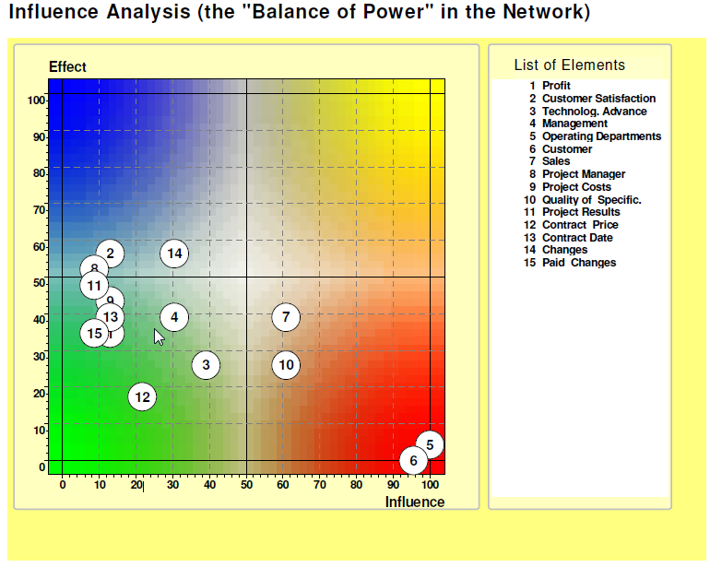

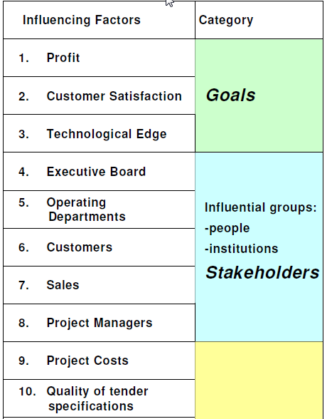

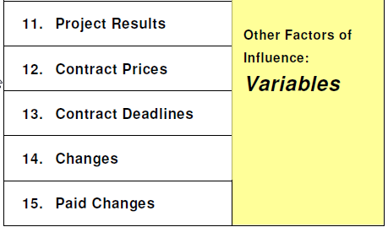

Segunda rodada compreende as semanas 2 a 14 do projeto.

Terceira Fase - Semanas 15 a 19 do projeto

**Quarta fase -** semanas 20 a 39 do projeto